Contents

Outline of Evaluations and Estimated Time 2

Participant Screening Form 3

Participant Randomization Form 4

Participant Baseline Information Form 5

Participant Personal Information Form 7

6 and 12 Month Follow Up Information Form 8

6 and 12 Month Step Activity Monitor Form 9

Outcome Measures 10

5 Meter Walk Evaluation Form 10

6 Minute Walk Evaluation Form 11

Berg Balance Scale Evaluation Form 12

Isometric Knee Extension 16

EQ-5D-5L Evaluation Form 17

Cognitive Evaluation Forms 19

Montreal Cognitive Assessment (MOCA) 19

Digit Symbol Substitution Test (DSST) 20

Trail Making A 21

Trail Making B 23

NIH Stroke Scale 25

Functional Independence Measure (FIM) 29

Patient Health Questionnaire (PHQ-9) 31

Godin Leisure-Time Exercise Questionnaire 32

# Outline of Evaluations and Estimated Time

|  |  |  |  |  |
| --- | --- | --- | --- | --- |
| **Screening Evaluation** | **Baseline Evaluation** | **Post Evaluation** | **6 month Evaluation** | **12 month Evaluation** |
| Consent | 5 meter walk (comfortable)  *5 minutes* | 5 meter walk (comfortable) | 5 meter walk (comfortable) | 5 meter walk (comfortable) |
| Inclusion/Exclusion Criteria | Functional Ambulation Status  *1 minute* | Functional Ambulation Status | Functional Ambulation Status | Functional Ambulation Status |
| Cardiac Stress Test  (if participants consents and meets study criteria) | FIM  (All Components)  *12 minutes* | FIM | 6 minute walk | 6 minute walk |
|  | Isometric Knee Extension  *1 minute* | Isometric Knee Extension  *1 minute* | Isometric Knee Extension  *1 minute* | Isometric Knee Extension  *1 minute* |
|  | NIH Stroke Scale  *8 minutes* | 6 minute walk | Berg Balance Scale | Berg Balance Scale |
|  | 6 minute walk  *10 minutes* | Berg Balance Scale | EQ-5D-5L | EQ-5D-5L |
|  | Berg Balance Scale  *15 minutes* | EQ-5D-5L | MOCA | MOCA |
|  | EQ-5D-5L  *5 minutes* | MOCA | DSST | DSST |
|  | MOCA  *8 minutes* | DSST | Trails A+B | Trails A+B |
|  | DSST  *3 minutes* | Trails A+B | PHQ-9 | PHQ-9 |
|  | Trails A+B  *10 minutes* | PHQ-9 | Step Activity Monitor Form | Step Activity Monitor Form |
|  | PHQ-9  *10 minutes* |  |  |  |
|  | Godin Leisure Time Exercise Questionnaire  *1 minute* |  |  |  |
|  | **Total est. time:**  **89 minutes** | **Total est. time:**  **79 minutes** | **Total est. time:**  **68 minutes** | **Total est. time:**  **68 minutes** |

# Participant Screening Form

1. Interviewer’s Initials: __ __ (First/Last) Interview Date: M____D_____Yr____
2. Screening ID: ________________
3. Signed Consent Form: Yes No
4. Date of Consent: M_____D______Yr______
5. Gender: M□ F□
6. Date of Birth: M____D_____Yr____
7. Confirmation that patient will be discharged to local inpatient stroke rehab? □ Yes □ No

Date Physiatry consult completed: M_____D_____Yr_____

1. Inclusion Criteria:

Participant is included in the study if:

1. Yes No Within 4 weeks post hemorrhagic or ischemic CVA
2. Yes No Pre-stroke disability <2 (less than 2) on the Modified Rankin Scale.
3. Yes No Able to ambulate at least 15 feet (5 m distance). May use assistive

and/or orthotic device and maximum one person assist.

1. Yes No Overground walking speed less than 1.0m/s (over a 5 m distance)
2. Yes No Able to understand and follow directions
3. Yes No Greater than or equal to 19 years of age.
4. Exclusion Criteria:

Participant is excluded in the study if:

1. Yes No Pre-stroke health included a gait disorder or disease that affected

ambulation (musculoskeletal conditions, amputation, etc.)

1. Yes No Pre-stroke health included a neurological condition (such as Parkinson’s

disease or Multiple Sclerosis) or other serious medical condition (active cancer, uncontrolled diabetes)

1. Yes No Excessive pain in the body/joint preventing participation in an exercise

intervention.

1. Yes No Participating in an experimental drug field study.
2. Yes No Participating in another formal exercise rehabilitation clinical trial.
3. □ Yes □ No Participant meets study criteria and would like to proceed with study.
4. □ Yes □ No Participant meets study criteria, but does not want to proceed with study.

Comment:___________________________________________________

1. □ Yes □ No Participant does not meet study criteria AT THIS TIME, but would like to be re-

evaluated for the study in one week.

Comment:___________________________________________________

13. □ Yes □ No Participant does not meet study criteria.

Comment:___________________________________________________

# Participant Randomization Form

1. Interviewer’s Initials: __ __ (First/Last) Interview Date: M____D_____Yr____
2. Screening ID: __________________
3. Gender: M□ F□
4. Date of Birth: M____D_____Yr____

1. FIM Transfer Status: □ > 5 (Greater than or equal to 5) □ <5 (Less than 5)
2. Study Site: GF Strong□ Holy Family □ Fanning□ Foothills□ Toronto Rehab□
3. Age: □ >60 (greater than or equal to 60) □ <60 (less than 60)
4. Meets all study inclusion criteria (Participant Screening Form): □ Yes □No
5. Passed exercise stress test: □ Yes □ No
6. Signed consent form: □ Yes □ No Date consent signed: M____D_____Yr____

**ASSIGNED STUDY ID:** _______________

Initials of individual completing randomization: __ __ (First/Last)

Date of randomization: M____D_____Yr____

# Participant Baseline Information Form

1. Interviewer’s Initials: __ __ (First/Last) Date: M____D_____Yr____
2. Study ID:________________
3. Gender: M□ F□ ; Height: _______ Weight: _________ Waist Circumference_______
4. Birthdate: M ____ D_____ Yr_______
5. Date of Stroke: M_____D_____Yr_____
6. Rehab Admission Date: M____D____Yr____
7. Brain Hemisphere Affected : □ R □ L
8. Limb(s) Affected: □ UE □ LE
9. Dominant Hand (prior to stroke): □ R □ L
10. Recurrent Stroke: □ Yes □ No (if Yes, same side? ______; how many times? _______)
11. Pre-Stroke Disability (Modified Rankin Scale): □ 0 □ 1 □ 2 □ 3 □ 4 □ 5
12. Stroke Information Obtained from: □ CT □ MRI
13. Stroke Type: [ ] Lacunar [ ] Infarct [ ] Hemorrhagic [ ] Unknown
14. Stroke Location: [ ] Cortical [ ] Subcortical [ ] Unknown
15. Vessel Affected: [ ] MCA [ ] ACA [ ] PCA [ ] Other, specify
16. Diabetes mellitus: ❒yes ❒no ❒unknown

If yes, criteria: (✓ all that apply)

❒self-reported

❒taking antidiabetic medication

❒ elevated glucose in medical records

1. Hypertension: ❒ yes ❒ no ❒ unknown

If yes, criteria: (✓ all that apply)

❒ self-reported

❒taking a medication specifically for lowering BP

❒high blood pressures in medical records

❒history of hypertension in medical records

1. Current Medication: _________________________________________________ ______________________________________________________________________ ______________________________________________________________________
2. Tobacco use:

□ never smoked

□ former smoker, year stopped __ __ __ __ years smoked __ __

average cigarettes per day __ __ and/or □ pipe/cigars

□ current smoker, years smoked __ __

average cigarettes per day __ __ and/or □ pipe/cigars

1. Years of Formal Education: _________________ (high school = 12 years, add years post-secondary)
2. Spoken Language preference:

□ English (>90%)

□ Chinese (>90%)

□ French (>90%)

□ Other (>90%) ___________________________

□ Two languages spoken regularly

At home, which >50% of time? □English □Chinese □French □Other

1. Ethnicity:

□ White (Caucasian)

□ Aboriginal (First Nations person, Metis, Inuit)

□ Black

□ Latin American

□ South Asian (East Indian, Pakistani, Sri Lankan, etc.)

□ East Asian (Chinese, Vietnamese, Filipino, Korean, etc.)

□ More than one or other:__________

1. Marital Status:

□ Never married

□ Married/Common Law

□ Separated/Divorced

□ Widowed

1. Living Arrangements (Prior to stroke):

□ Alone in house or apartment

□ With spouse/relatives/others in home or apartment

□ Assisted living facility or nursing home or other paid caregiver

□ Other

# Participant Personal Information Form

*This form will not be entered into the database – it is kept for contact information for the 6 and 12 month follow up evaluations. This form will be stored in a locked filing cabinet at the study site where the participant is enrolled.

1. Participant Name:
2. Screening ID:
3. Assigned Study ID:
4. Birthdate: M ____ D_____ Yr_______
5. Gender: M□ F□
6. Patient Contact Phone Number: ______________
7. Patient address: ___________________________________________________________
8. Family/Friend contact_____________________Relation_________________________

Phone number:________________

Address: ____________________________________________________

9. Medications:

# 6 and 12 Month Follow Up Information Form

1. Interviewer’s Initials: __ __ (First/Last) Date: M____D_____Yr____
2. Study ID:________________
3. Follow up evaluation: 6 month□ 12 month□
4. Patient address and contact phone number same as data on personal information form?

Yes□ No□

If new address and/or phone number, make change on personal information form and date.

1. Family/friend contact information same as data on personal information form?

Yes□ No□

If new information, make change on personal information form and date.

1. Any change in health/functional status since last evaluation?: Yes□ No□

Comments:

1. Any change in medications since last evaluation?: Yes□ No□

(*Interviewer compares meds to those on participant’s baseline/6 month evaluation form)

Comments:

1. Any change in living situation since last evaluation?: Yes□ No□

Comments:

1. Any falls since last evaluation? Yes□ No□ # of falls:_____

If appropriate list approximate date(s), reason for fall, injury sustained:

1. Any formal therapy received since last evaluation?: Yes□ No□

(If appropriate list type of therapy/frequency/duration):

1. Participation in any formal exercise/rehabilitation study since last evaluation?: Yes□ No□

Comments:

# 6 and 12 Month Step Activity Monitor Form

**Participant’s Study ID: _____________________**

**Evaluation:** **1.** 6 month follow up

**2.** 12 month follow up

**Evaluation Date: ___ ___/___ ___/___ ___ ___ ___**

Month Day Year

**Evaluator’s Initials:**

First/Last

(Note: Data obtained from the accelerometers that the participant wears for a 4 day period either before or after the 6 month and 12 month evaluation)

1. Total number of steps: ________Day 1

________Day 2

________Day 3

________Day 4

1. Energy Expenditure: ________Day 1

________Day 2

________Day 3

________Day 4

# Outcome Measures

## 5 Meter Walk Evaluation Form

1. **Participant’s Study ID: _____________________**

**2. Evaluation:** **1.** Baseline

**2.** Post-Treatment

**3.** 6 month follow up

**4.** 12 month follow up

**3. Evaluation Date: ___ ___/___ ___/___ ___ ___ ___**

Month Day Year

**4. Evaluator’s Initials:**

First/Last

5 METER WALK TEST

Time (in seconds) to walk 5 meters:

“Comfortable” (Self-Selected)Pace:

a. Trial 1: “Comfortable Pace” - Number of seconds: ___ ___ ___.___ ___sec

b. Trial 2: “Comfortable Pace” - Number of seconds: ___ ___ ___.___ ___sec

c. Assistive Device: ___ 0 None

1 Single point cane

2 Quad cane

3 2 wheeled walker

4 Standard walker

5 Other________________

d. Type of AFO: ___ 0 None

1 Rigid Plastic (no joint)

2 Rigid Plastic (with joint)

3. Other________________

e) FAC:___ 2 Ambulator – Dependent for Physical Assistance Level II

3 Ambulator – Dependent for Physical Assistance Level I

4 Ambulator – Dependent for Supervision

5 Ambulator – Independent, Level surfaces only

6 Ambulator – Independent, Level and non-level surfaces

## 6 Minute Walk Evaluation Form

1. **Participant’s Study ID: _____________________**

**2. Evaluation:** **1.** Baseline

**2.** Post-Treatment

**3.** 6 month follow up

**4.** 12 month follow up

**3. Evaluation Date: ___ ___/___ ___/___ ___ ___ ___**

Month Day Year

**4. Evaluator’s Initials:**

First/Last

5. Height: _________ cm ; Weight: _________ kg

6. Rest HR: ___________ ; Rest BP: ________ / ________

Peak HR: ___________ ; Peak BP: ________ / ________

7. Distance covered in 6 minutes: ____________meters

8. Assistive Device: ___ 0 None

1 Single point cane

2 Quad cane

3 2 wheeled walker

4 Standard walker

5 Other________________

9. Type of AFO: ___ 0 None

1. Rigid Plastic (no joint)
2. Rigid Plastic (with joint)
3. Other_____________

10. FAC:___ 2 Ambulator – Dependent for Physical Assistance Level II

3 Ambulator – Dependent for Physical Assistance Level I

4 Ambulator – Dependent for Supervision

5 Ambulator – Independent, Level surfaces only

6 Ambulator – Independent, Level and non-level surfaces

## Berg Balance Scale Evaluation Form

1. **Participant’s Study ID: _____________________**

**2. Evaluation:** **1.** Baseline

**2.** Post-Treatment

**3.** 6 month follow up

**4.** 12 month follow up

**3. Evaluation Date: ___ ___/___ ___/___ ___ ___ ___**

Month Day Year

**4. Evaluator’s Initials:**

First/Last

The Berg Balance Scale (BBS) is a 14-item scale to measure balance among people with impairment in balance function by assessing the performance of functional tasks in a clinical setting.

**Equipment needed:**

Ruler, bed and chair or two standard chairs, footstool or step, stopwatch or wristwatch.

**Scoring:**

A five-point scale, ranging from 0-4. “0” indicates the lowest level of function and “4” the highest level of function. Total Score = 56

**Instructions:**

Grading: Please mark the category which applies.

1. **Sitting to Standing from a chair**

Instruction: *Please stand up. Try not to use your hands for support*.

Grading:

4: Able to stand no hands and stabilize independently.

3: Able to stand independently using hands.

2: Able to stand using hands after several tries.

1: Needs minimal assistance to stand or to stabilize.

0: Needs moderate or maximal assistance to stand.

1. **Standing Unsupported**

Instruction: *Stand for two minutes without holding*.

Grading:

4: Able to stand safely 2 minutes.

3: Able to stand 2 minutes with supervision.

2: Able to stand 30 seconds unsupported.

1: Needs several tries to stand 30 seconds unsupported.

0: Unable to stand 30 seconds unassisted.

1. **Sitting Unsupported Feet on Floor (do not test if patient is independent in standing or walking, just score 4)**

Instruction*: Sit with arms folded for two minute*.

Grading:

4: Able to sit safely and securely 2 minutes.

3: Able to sit 2 minutes under supervision.

2: Able to sit 30 seconds.

1: Able to sit 10 seconds.

0: Unable to sit without support 10 seconds.

1. **Standing to Sitting**

Instruction: *Please sit down*.

Grading:

4: Sits safely with minimal use of hands.

3: Controls descent by using hands.

2: Uses back of legs against chair to control descent.

1: Sits independently but has uncontrolled descent.

0: Needs assistance to sit.

1. **Transfers**

Instruction: *Please move from chair to bed and back again. One way toward a seat with arm rests and one way toward a seat without arm rests*.

If a bed/plinth is used, it should be lowered and close to a chair seat height.

Grading:

4: Able to transfer safely with minor use of hands.

3: Able to transfer safely definite need of hands.

2: Able to transfer with verbal cuing and/or supervision.

1: Needs one person to assist.

0: Needs two people to assist or supervise to be safe.

1. **Standing Unsupported with Eyes Closed**

Instruction*: Close your eyes and stand still for 10 seconds*.

Grading:

4: Able to stand 10 seconds safely.

3: Able to stand 10 seconds with supervision.

2: Able to stand 3 seconds.

1: Unable to keep eyes closed 3 seconds but stays steady.

0: Needs help to keep from falling.

1. **Standing Unsupported with Feet Together**

Instruction: *Place your feet together and stand without holding*.

Grading:

4: Able to place feet together independently and stand 1 minute safely.

3: Able to place feet together independently and stand for 1 minute with supervision.

2: Able to place feet together independently but unable to hold for 30 seconds.

1: Needs help to attain position but able to stand 15 seconds with feet together.

0: Needs help to attain position and unable to hold for 15 seconds.

1. **Reaching Forward with Outstretched Arm**

Instruction: *Lift arm to 90 degrees. Stretch out your fingers and reach forward as far as you can*. (Examiner places a ruler at end of fingertips when arm is at 90 degrees. Fingers should not touch the ruler while reaching forward. The recorded measure is the distance forward that the fingers reach while the subject is in the most forward lean position).

Grading:

4: Can reach forward confidently more than 10 inches.

3: Can reach forward more than 5 inches safely.

2: Can reach forward more than 2 inches safely.

1: Reaches forward but needs supervision.

0: Needs help to keep from falling. * **_________inches**

1. **Pick Up Object from the Floor**

Instruction*: Pick up the shoe/slipper which is placed in front of your feet*.

Grading:

4: Able to pick up slipper safely and easily.

3: Able to pick up slipper but needs supervision.

2: Unable to pick up but reaches 1 to 2 inches from slipper and keeps balance independently.

1: Unable to pick up and needs supervision while trying.

0: Unable to try/needs assistance to keep from falling.

1. **Turning to Look Behind Over Left and Right Shoulders**

Instruction: *Turn to look behind you over toward left shoulder. Repeat to the right*.

Grading:

4: Looks behind from both sides and weight shifts well.

3: Looks behind one side only; other side shows less weight shift.

2: Turns sideways only but maintains balance.

1: Needs supervision when turning.

0: Needs assistance to keep from falling.

1. **Turn 360 Degrees**

Instruction: *Turn completely around in a full circle. Pause. Then turn a full circle in the other direction*.

Grading:

4: Able to turn 360 degrees safely in less than 4 seconds each side.

3: Able to turn 360 degrees safely one side only – less than 4 seconds.

2: Able to turn 360 degrees safely but slowly.

1: Needs close supervision or verbal cuing.

0: Needs assistance while turning.

1. **Step on Stool**

Instruction*: Place each foot alternately on the stool. Continue until each foot has touched the stool four times*.

Grading:

4: Able to stand independently and safely and complete 8 steps in 20 seconds.

3: Able to stand independently and complete 8 steps in more than 20 seconds.

2: Able to complete 4 steps without aid with supervision.

1: Able to complete more than 2 steps – needs minimal assistance.

0: Needs assistance to keep from falling – unable to try.

1. **Standing Unsupported One Foot in Front**

Instruction: *Place one foot directly in front of the other. If you feel that you cannot place your foot directly in front, try to step far enough ahead that the heel of your forward foot is ahead of the toes of the other foot.* (DEMONSTRATE to subject.)

Grading:

4: Able to place foot tandem independently and hold 30 seconds.

3: Able to place foot ahead of the other independently and hold 30 seconds.

2: Able to take small step independently and hold 30 seconds.

1: Needs help to step but can hold 15 seconds.

0: Loses balance while stepping or standing.

1. **Standing on One Leg**

Instruction: *Stand* *on one leg (****your stroke affected side****) as long as you can without holding*.

Grading:

4: Able to lift leg independently and hold more than 10 seconds.

3: Able to lift leg independently and hold 5 to 10 seconds.

2: Able to lift leg independently and hold at least 3 seconds.

1: Tries to lift leg, unable to hold 3 seconds but remains standing independently.

0: Unable to try or needs assistance to prevent fall.

**TOTAL SCORE:____/56**

## Isometric Knee Extension

1. **Participant’s Study ID: _____________________**

**2. Evaluation:** **1.** Baseline

**2.** Post-Treatment

**3.** 6 month follow up

**4.** 12 month follow up

**3. Evaluation Date: ___ ___/___ ___/___ ___ ___ ___**

Month Day Year

**4. Evaluator’s Initials:**

First/Last

Paretic lower extremity: □ R □ L ____________newtons/kg

Non-paretic lower extremity: □ R □ L ____________newtons/kg

## EQ-5D-5L Evaluation Form

**Participant’s Study ID: _____________________**

**2. Evaluation:** **1.** Baseline

**2.** Post-Treatment

**3.** 6 month follow up

**4.** 12 month follow up

**3. Evaluation Date: ___ ___/___ ___/___ ___ ___ ___**

Month Day Year

**4. Evaluator’s Initials:**

First/Last

Under each heading, please tick the ONE box that best describes your health TODAY.

**MOBILITY**

* I have no problems in walking about
* I have slight problems in walking about
* I have moderate problems in walking about
* I have severe problems in walking about
* I am unable to walk about

**SELF-CARE**

* I have no problems washing or dressing myself
* I have slight problems washing or dressing myself
* I have moderate problems washing or dressing myself
* I have severe problems washing or dressing myself
* I am unable to wash or dress myself

**USUAL ACTIVITIES *(e.g. work, study, housework, family or leisure activities)***

* I have no problems doing my usual activities
* I have slight problems doing my usual activities
* I have moderate problems doing my usual activities
* I have severe problems doing my usual activities
* I am unable to do my usual activities

**PAIN /DISCOMFORT**

* I have no pain or discomfort
* I have slight pain or discomfort
* I have moderate pain or discomfort
* I have severe pain or discomfort
* I have extreme pain or discomfort

**ANXIETY /DEPRESSION**

* I am not anxious or depressed
* I am slightly anxious or depressed
* I am moderately anxious or depressed
* I am severely anxious or depressed
* I am extremely anxious or depressed

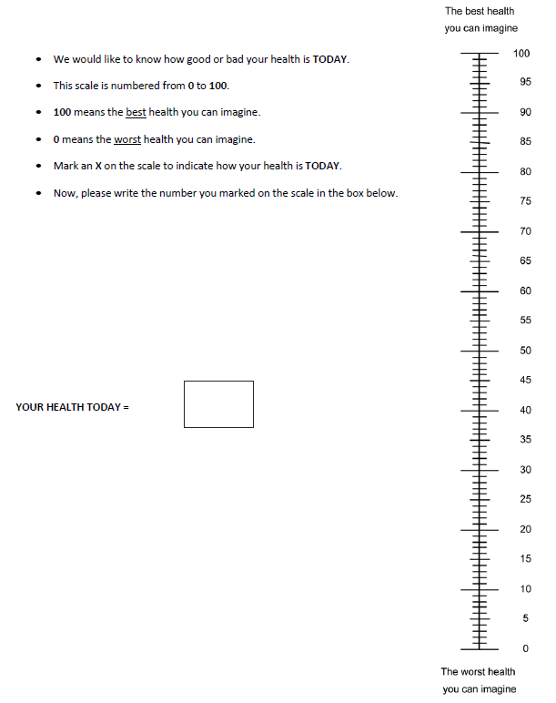

**Participant’s Study ID: _______**

**2. Evaluation:** **1.** Baseline

**2.** Post-Treatment

**3.** 6 month follow up

**4.** 12 month follow up

**3. Evaluation Date: ___ ___/___ ___/___ ___ ___ ___**

Month Day Year

**4. Evaluator’s Initials:**

First/Last

## Cognitive Evaluation Forms

### Montreal Cognitive Assessment (MOCA)

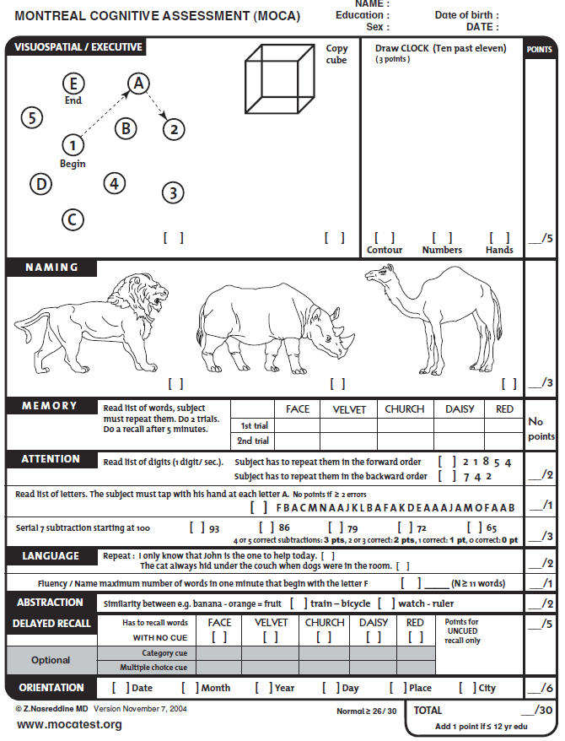

### Digit Symbol Substitution Test (DSST)

1. **Participant’s Study ID: _______**

**2. Evaluation:** **1.** Baseline

**2.** Post-Treatment

**3.** 6 month follow up

**4.** 12 month follow up

**3. Evaluation Date: ___ ___/___ ___/___ ___ ___ ___**

Month Day Year

**4. Evaluator’s Initials:**

First/Last

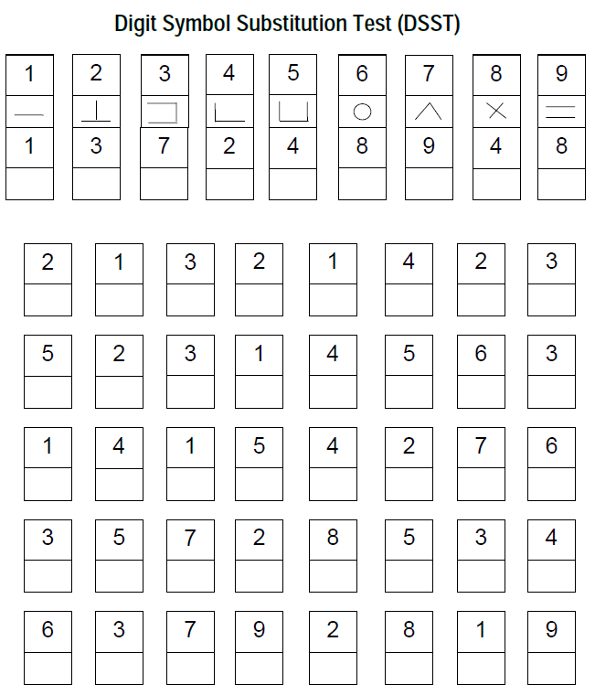

### Trail Making A

1. **Participant’s Study ID: _______**

**2. Evaluation:** **1.** Baseline

**2.** Post-Treatment

**3.** 6 month follow up

**4.** 12 month follow up

**3. Evaluation Date: ___ ___/___ ___/___ ___ ___ ___**

Month Day Year

**4. Evaluator’s Initials:**

First/Last

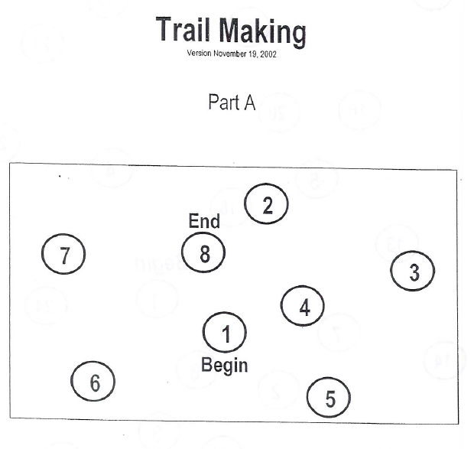

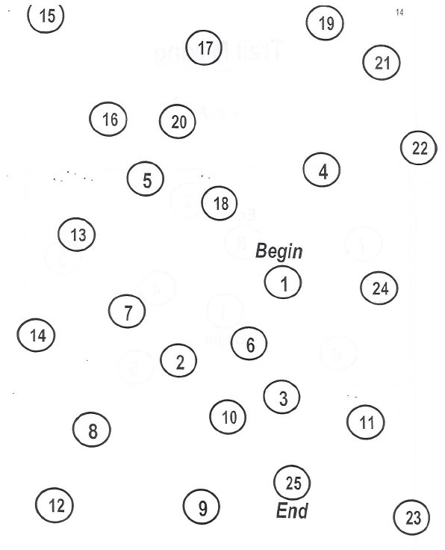**Trail Making A**

### Trail Making B

1. **Participant’s Study ID: _______**

**2. Evaluation:** **1.** Baseline

**2.** Post-Treatment

**3.** 6 month follow up

**4.** 12 month follow up

**3. Evaluation Date: ___ ___/___ ___/___ ___ ___ ___**

Month Day Year

**4. Evaluator’s Initials:**

First/Last

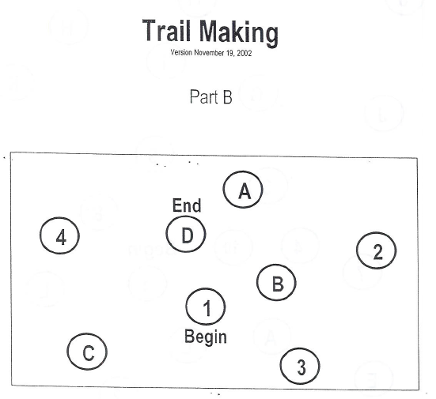

**Trail Making Part B**

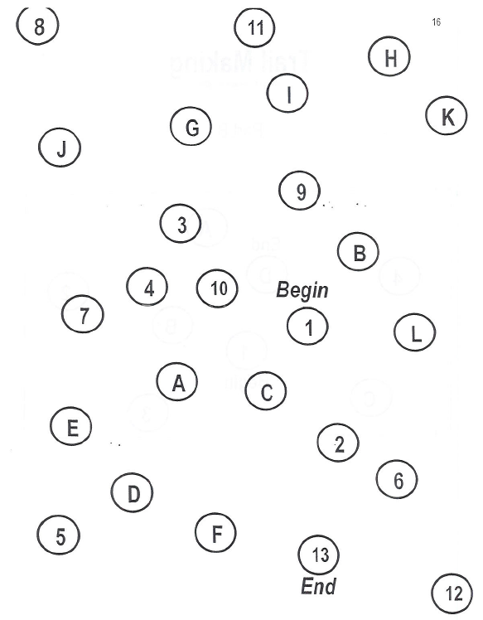

## NIH Stroke Scale

*To be completed at baseline only*

**Participant’s Study ID: _____________________**

**2. Evaluation:** **1.** Baseline

**3. Evaluation Date: ___ ___/___ ___/___ ___ ___ ___**

Month Day Year

**4. Evaluator’s Initials:**

First/Last

Administer stroke scale items in the order listed. Record performance in each category after each subscale exam. Do not go back and change scores. Follow directions provided for each exam technique. Scores should reflect what the patient does, not what the clinician thinks the patient can do. The clinician should record answer while administering the exam and work quickly. Except where indicated, the patient should not be coached (i.e., repeated requests to patient to make a special effort.

IF ANY ITEM IS LEFT UNTESTED, A DETAILED EXPLANATION MUST BE CLEARLY WRITTEN ON THE FORM. ALL UNTESTED ITEMS WILL BE REVIEWED BY THE MEDICAL MONITOR, AND DISCUSSED WITH THE EXAMINER BY TELEPHONE.

|  |  |  |
| --- | --- | --- |
| **Instructions** | **Scale Definition** | **Score** |
| 1a. Level of Consciousness: The investigator must choose a response, even if a full evaluation is prevented by such obstacles as an endotracheal tube, language barrier, and orotracheal trauma/bandages. A 3 is scored only if the patient makes no movement (other than reflexive posturing) in response to noxious stimulation. | 0 = Alert; keenly responsive.  1 = Not alert, but arousable by minor stimulation to obey, answer, or respond.  2 = Not alert, requires repeated stimulation to attend, or is obtuned and requires strong or painful stimulation to make movements (not stereotyped).  3 = Responds only with reflex motor or autonomic effects or totally responsive, flaccid, areflexic. | _______ |
| 1b. LOC Questions: The patient is asked the month and his/her age. The answer mist be correct – there is no partial credit for being close. Aphasic and stuporous patients who do not comprehend the questions will score 2. Patients unable to speak because of endotracheal intubation, orotracheal trauma, severe dysarthia from any cause, language barrier or any other problem not secondary to aphasia are given a 1. It is important that only the initial answer be graded and that the examiner not “help” the patient with verbal or non-verbal cues. | 0 = Answers both questions correctly    1 = Answers one question correctly  2 = Answers neither question correctly | _______ |
| 1c. LOC Commands: The patient is asked to open and close the eyes and then to grip and release the non-paretic hand. Substitute another one step command if the hands cannot be used. Credit is given if an unequivocal attempt is made but not completed due to weakness. If the patient does not respond to command, the task should be demonstrated to them (pantomime) and score the result (i.e., follows none, one or two commands). Patients with trauma, amputation, or other physical impediments should be given suitable one-step commands. Only the first attempt is scored. | 0 = Performs both tasks correctly  1 = Performs one task correctly  2 = Performs neither task correctly | _______ |
| 2. Best Gaze: Only horizontal eye movements will be tested. Voluntary or reflexive (oculocephalic) eye movements will be scored but caloric testing is not done. If the patient has a conjugate deviation of the eyes that can be overcome by voluntary or reflexive activity, the score will be 1. If a patient has an isolated peripheral nerve paresis (CN III, IV or VI) score a 1. Gaze is testable in all aphasic patients. Patients with ocular trauma, bandages, pre-existing blindness or other disorder of visual acuity of fields should be tested with reflexive movements and a choice made by the investigator. Establishing eye contact and then moving about the patient from side to side will occasionally clarify the presence of a partial gaze palsy. | 0 = Normal  1 = Partial gaze palsy. This score is given when gaze is abnormal in one or both eyes, but where forced deviation or total gaze paresis are not present.  2 = Forced deviation, or total gaze paresis not overcome by the oculocephalic maneuver. | _______ |
| 3. Visual: Visual fields (upper and lower quadrants) are tested by confrontation, using finger counting or visual threat as appropriate. Patient must be encouraged, but if they look at the side of the moving fingers appropriately, this can be scored as normal. If there is unilateral blindness or enucleation, visual fields in the remaining eye are scored. Score 1 only if a clear-cut asymmetry, including quadrantanopia is found. If patient is blind from any cause score 3. Double simultaneous stimulation is performed at this point. If there is extinction patient receives a 1 and the results are used to answer question 11. | 0 = No visual loss  1 = Partial hemianopia  2 = Complete hemianopia  3 = Bilateral hemianopia (blind including cortical blindness) | _______ |
| 4. Facial Palsy: Ask, or use pantomime to encourage the patient to show teeth or raise eyebrows and close eyes. Score symmetry of grimace in response to noxious stimuli in the poorly responsive or non-comprehending patient. If facial trauma/bandages, orotracheal tube, tape or other physical barrier obscures the face, these should be removed to the extent possible. | 0 = Normal symmetrical movement  1 = Minor paralysis (flattened nasolabial fold, asymmetry on smiling)  2 = Partial paralysis (total or near total paralysis of lower face)  3 = Complete paralysis of one or both sides (absence of facial movement in the upper and lower face) | _______ |
| 5 & 6. Motor Arm and Leg: The limb is placed in the appropriate position: extend the arms (palms down) 90 degrees (if sitting) or 45 degrees (if supine) and the leg 30 degrees (always tested supine). Drift is scored if the arm falls before 10 seconds or the leg before 5 seconds. The aphasic patient is encouraged using urgency in the voice and pantomime but not noxious stimulation. Each limb is tested in turn, beginning with the non-paretic arm. Only in the case of amputation or joint fusion at the shoulder or hip may the score be “9” and the examiner must clearly write the explanation for scoring as a “9.” | 0 = No drift, limb holds 90 (or 45) degrees for full 10 seconds.  1 = Drift, limb holds 90 (or 45) degrees, but drifts down before full 10 seconds; does not hit bed or other support.  2 = some effort against gravity, limb cannot get to or maintain (if cued) 90 (or 45) degrees, drifts down to bed, but has some effort against gravity.  3 = No effort against gravity, limb falls.  4 = No movement  9 = amputation or joint fusion, explain: _______________  5a. Left Arm  5b. Right Arm | _______  _______ |
| 6. Motor Leg | 0 = No drift, leg holds for 30 degrees position for full 5 seconds.  1 = drift, leg falls by the end of the 5 second period but does not hit bed.  2 = Some effort against gravity; leg falls to bed by 5 seconds, but has some effort against gravity.  3 = No effort against gravity, leg falls to bed immediately.  4 = No movement  9 = amputation or joint fusion, explain: _______________  6a. Left Leg  6b. Right Leg | _______  _______ |
| 7. Limb Ataxia: This item is aimed at finding evidence of a unilateral cerebellar lesion. Test with eyes open. In case of visual defect, insure testing is done in intact visual field. The finger-nose-finger and heel-shin tests are performed on both side, and ataxia is scored only is present in the patient who cannot understand or is paralyzed. Only in the case of amputation or joint fusion may the item be scored “9”, and the examiner must clearly write the explanation for not scoring. Incase of blindness test by touching nose from extended arm position. | 0 = Absent  1 = Present in one limb  2 = Present in two limbs  If present, is ataxia in  Right arm 1 = Yes 2 = No  9 = amputation or joint fusion, explain: _______________  Left arm 1 = Yes 2 = No  9 = amputation or joint fusion, explain: _______________  Right leg 1 = Yes 2 = No  9 = amputation or joint fusion, explain: _______________  Left leg 1 = Yes 2 = No  9 = amputation or joint fusion, explain: _______________ | _______  _______  _______  _______ |
| 8. Sensory: Sensation or grimace to pin prick when tested, or withdrawal from noxious stimulus in the obtunded or aphasic patient. Only sensory loss attributed to stroke is scored as abnormal and the examiner should test as many body areas [arms (not hands), legs, trunk, face] as needed to accurately check for hemisensory loss. A score of 2, “severe or total,” should only be given when a severe or total loss of sensation can be clearly demonstrated. Stuporous and aphasic patients will therefore probably score 1 or 0. The patient with brain stem stroke who has bilateral loss of sensation is scored 2. If the patient does not response and is quadriplegic score 2. Patients in coma (item 1a=3) are arbitrarily given a 2 on this item. | 0 = Normal; no sensory loss.  1 = Mild to moderate sensory loss; patient feels pinprick is less sharp or is dull on the affected side; or there is a loss of superficial pain with pinprick but patient is aware he/she is being touched.  2 = Severe to total sensory loss; patient is not aware of being touched in the face, arm, and leg. | _______ |

|  |  |  |
| --- | --- | --- |
| 9. Best Language: A great deal of information about comprehension will be obtained during the preceding sections of the examination. The patient is asked to describe what is happening in the attached picture, to name the items on the attached naming sheet, and to read from the attached list of sentences. Comprehension is judged from responses here as well as to all of the commands in the preceding general neurological exam. If visual loss interferes with the tests, ask the patient to identify objects placed in the hand, repeat, and produce speech. The intubated patient should be asked to write. The patient in coma (question 1a=3) will arbitrarily score 3 on this item. The examiner must choose a score in the patient with stupor or limited cooperation but a score of 3 should be used only if the patient is mute and follows no one step commands. | 0 = No aphasia, normal  1 = Mild to moderate aphasia; some obvious loss of fluency or facility of comprehension, without significant limitation on ideas expressed or form of expression. Reduction of speech and/or comprehension, however, makes conversation about provided material difficult or impossible. For example in conversation about provided materials examiner can identify picture or naming card from patient’s response.  2 = Severe aphasia; all communication is through fragmentary expression; great need for inference, questioning, and guessing by the listener. Range of information that can be exchanged is limited; listener carries burden of communication. Examiner cannot identify materials provided from patient response.  3 = Mute, global aphasia; no usable speech or auditory comprehension. | _______ |
| 10. Dysarthria: If patient is thought to be normal an adequate sample of speech must be obtained by asking patient to read or repeat words from the attached list. If the patient has severe aphasia, the clarity of articulation of spontaneous speech can be rated. Only if the patient is intubated or has other physical barrier to producing speech, may the item be scored “9”, and the examiner must clearly write an explanation for not scoring. Do not tell the patient why he/she is being tested. | 0 = Normal  1 = Mild to moderate; patient slurs at least some words and, at worst, can be understood with some difficulty.  2 = Severe; patient’s speech is so slurred as to be unintelligible in the absence of or out of proportion to any dysphasia, or is mute/anarthric.  9 = Intubated or other physical barrier, explain:  ______________________________ | _______ |
| 11. Extinction and inattention (formerly Neglect): Sufficient information to identify neglect may be obtained during the prior testing. If the patient has a severe visual loss preventing visual double simultaneous stimulation, and the cutaneous stimuli are normal, the score is normal. If the patient has aphasia but does appear to attend to both sides, the score is normal. The presence of visual spatial neglect or anosagnosia may also be taken as evidence of abnormality. Since the abnormality is scored only if present, the item is never untestable. | 0 = No abnormality  1 = Visual, tactile, auditory, spatial, or personal inattention or extinction to bilateral simultaneous stimulation in one of the sensory modalities.  2 = Profound hemi-inattention or hemi-inattention to more than one modality. Does not recognize own hand or orients to only one side of space. | _______ |

|  |
| --- |
| **NIH TOTAL SCORE _______________** |

## Functional Independence Measure (FIM)

The FIM consists of 18 items assessing 6 areas of function (Self-care, Sphincter control, Mobility, Locomotion, Communication and Social cognition). The items fall into two domains: Motor (13 items) and Cognitive (5 items). The motor items are based on the items of the Barthel Index. These domains are referred to as the Motor-FIM and the Cognitive-FIM.

**Scoring:**

Each item on the FIM is scored on a 7-point Likert scale, and the score indicates the amount of assistance required to perform each item (1 = total assistance in all areas, 7 = total independence in all areas). A final summed score is created and ranges from 18 - 126, where 18 represents complete dependence/total assistance and 126 represents complete independence. Subscale scores for the Motor and Cognitive domains can also be calculated.

1. A score of **1** = **Total Assistance**, in which the person puts forth less than 25% of the effort necessary to do a task.
2. A score of **2** = **Maximal Assistance**, in which the person puts forth less than 50% of the effort necessary to do a task, but at least 25%. If someone gets a score of "1" or "2" on the FIM scale, he/she is classified as having "Complete Dependence," because the person puts forth less than half the energy, requires maximal or total assistance, or the activity is not performed at all.
3. A score of **3 = Moderate Assistance**, in which the person puts forth between 50% and 74% of the effort necessary to do a task, and requires no more than helping or touching.
4. A score of **4 = Minimal Contact Assistance**, in which the person puts forth 75% or more of the effort necessary to do a task, and requires no more help than touching.
5. A score of **5 = Supervision or Setup**, in which the person only needs someone to standby and cue or coax him/her (without physical contact) so that he/she can do a task. A score of "5" can also be obtained if a helper is needed to set up items or assistive devices for the person. If someone gets a score of "3," "4," or "5," on the FIM scale, he/she is classified as having "Modified Dependence," because the person can at least put forth half or more of the energy to complete the task.
6. A score of **6 = Modified Independence**, in which no helper is needed and the person needs an assistive device. A score of "6" can also be obtained when no help is needed but the person takes more than a reasonable amount of time to do a task or may complete the task in an unsafe manner.
7. A score of **7 = Total Independence**, in which no helper is needed and the person performs the task safely, within a reasonable amount of time, and without assistive devices or aids. If someone gets a score of "6" or "7" on the FIM scale, he/she is classified as being "Independent," because another person is not needed to complete the activity.
8. **Participant’s Study ID: _______**

**2. Evaluation:** **1.** Baseline

**2.** Post-Treatment

**3. Evaluation Date: ___ ___/___ ___/___ ___ ___ ___**

Month Day Year

**4. Evaluator’s Initials:**

First/Last

**Functional Independence Measure (FIM)**

|  |  |
| --- | --- |
| **Items** | **Score** |
| **Self-Care** | |
| A. Eating |  |
| B. Grooming |  |
| C. Bathing |  |
| D. Dressing - Upper Body |  |
| E. Dressing - Lower Body |  |
| F. Toileting |  |
| **Sphincter Control** | |
| G. Bladder Management |  |
| H. Bowel Management |  |
| **Transfers** | |
| I. Bed, Chair, Wheelchair |  |
| J. Toilet |  |
| K. Tub, Shower |  |
| **Locomotion** | |
| L. Walk/Wheelchair |  |
| M. Stairs |  |
| ***Motor Subtotal Score*** |  |
| **Communication** | |
| N. Comprehension |  |
| O. Expression |  |
| **Social Interaction** | |
| P. Social Interaction |  |
| Q. Problem Solving |  |
| R. Memory |  |
| ***Cognitive Subtotal Score*** |  |
| **TOTAL FIM Score** |  |

## Patient Health Questionnaire (PHQ-9)

1. **Participant’s Study ID: _____________________**

**2. Evaluation:** **1.** Baseline

**2.** Post-Treatment

**3.** 6 month follow up

**4.** 12 month follow up

**3. Evaluation Date: ___ ___/___ ___/___ ___ ___ ___**

Month Day Year

**4. Evaluator’s Initials:**

First/Last

**Over the *last 2 weeks*, how often have you been bothered by any of the following problems?**

|  |  |  |  |  |
| --- | --- | --- | --- | --- |
|  | **Not at all** | **Several days** | **More than half the days** | **Nearly every day** |
| 1. Little interest or pleasure in doing things | **0** | **1** | **2** | **3** |
| 2. Feeling down, depressed, or hopeless | **0** | **1** | **2** | **3** |
| 3. Trouble falling or staying asleep, or sleeping too much | **0** | **1** | **2** | **3** |
| 4. Feeling tired or having little energy | **0** | **1** | **2** | **3** |
| 5. Poor appetite or overeating | **0** | **1** | **2** | **3** |
| 6. Feeling bad about yourself—or that you are a failure or have let yourself or your family down | **0** | **1** | **2** | **3** |
| 7. Trouble concentrating on things, such as reading the newspaper or watching television | **0** | **1** | **2** | **3** |
| 8. Moving or speaking so slowly that other people could have noticed. Or the opposite—being so fidgety or restless that you have been moving around a lot more than usual | **0** | **1** | **2** | **3** |
| 9. Thoughts that you would be better off dead, or of hurting yourself in some way | **0** | **1** | **2** | **3** |
| **Add columns:** | | **_______ + _______ + _______** | | |
| **TOTAL:** | |  | | |
| 10. If you checked off *any* problems, how *difficult* have these problems made it for you to do your work, take care of things at home, or get along with other people? | | **Not difficult at all**  _______  **Somewhat difficult**  _______  **Very difficult**  _______  **Extremely difficult**  _______ | | |

## Godin Leisure-Time Exercise Questionnaire

1. **Participant’s Study ID: _______**

**2. Evaluation:** **1.** Baseline

**3. Evaluation Date: ___ ___/___ ___/___ ___ ___ ___**

Month Day Year

**4. Evaluator’s Initials: ______/_______**

First/Last

**\***Evaluation done at baseline only*

**INSTRUCTIONS**

In this excerpt from the Godin Leisure-Time Exercise Questionnaire, the individual is asked to

complete a self-explanatory, brief four-item query of usual leisure-time exercise habits.

**CALCULATIONS**

For the first question, weekly frequencies of strenuous, moderate, and light activities are multiplied by nine, five, and three, respectively. Total weekly leisure activity is calculated in arbitrary units by summing the products of the separate components, as shown in the following formula:

Weekly leisure activity score = (9 × Strenuous) + (5 × Moderate) + (3 × Light)

The second question is used to calculate the frequency of weekly leisure-time activities pursued

“long enough to work up a sweat“ (see questionnaire).

**EXAMPLE**

Strenuous = 3 times/wk

Moderate = 6 times/wk

Light = 14 times/wk

Total leisure activity score = (9 × 3) + (5 × 6) + (3 × 14) = 27 + 30 + 42 = 99

**REFERENCE:**

Godin, G., Shephard, R. J.. (1997) Godin Leisure-Time Exercise Questionnaire. Medicine

and Science in Sports and Exercise. 29 June Supplement: S36-S38.

**Godin Leisure-Time Exercise Questionnaire**

1. During a typical **7-Day period** (a week), how many times on the average do you do the

following kinds of exercise for **more than 15 minutes** during your free time (write on each line

the appropriate number).

**a) STRENUOUS EXERCISE (HEART BEATS RAPIDLY) Times Per Week**  (e.g., running, jogging, hockey, football, soccer,

squash, basketball, cross country skiing, judo, **__________**

roller skating, vigorous swimming,

vigorous long distance bicycling)

**b) MODERATE EXERCISE (NOT EXHAUSTING)**

(e.g., fast walking, baseball, tennis, easy bicycling,

volleyball, badminton, easy swimming, alpine skiing, **__________**

popular and folk dancing)

**c) MILD EXERCISE (MINIMAL EFFORT)**

(e.g., yoga, archery, fishing from river bank, bowling,

horseshoes, golf, snow-mobiling, easy walking) **__________**

2. During a typical **7-Day period** (a week), in your leisure time, how often do you engage in any

regular activity **long enough to work up a sweat** (heart beats rapidly)?

**□ Often □ Sometimes □ Never/Rarely**

5-7 days/week 2-4 days/week 0-1 days/week